**Fast Decision**

The Fast decision helps C-suite peoples to handle the day to day operations under one roof. Our Fast decision application built on using various Microsoft features like PowerBI, Power Automate, Power Apps and Teams which enhance the top management to interact and collaborate with other team members or department for better decision making.

The below Dashboard is built on using powerBI and we incorporated those dashboard into Microsoft Teams so that C-suite executives are not required to switch between applications or systems to get to know the overall happenings.

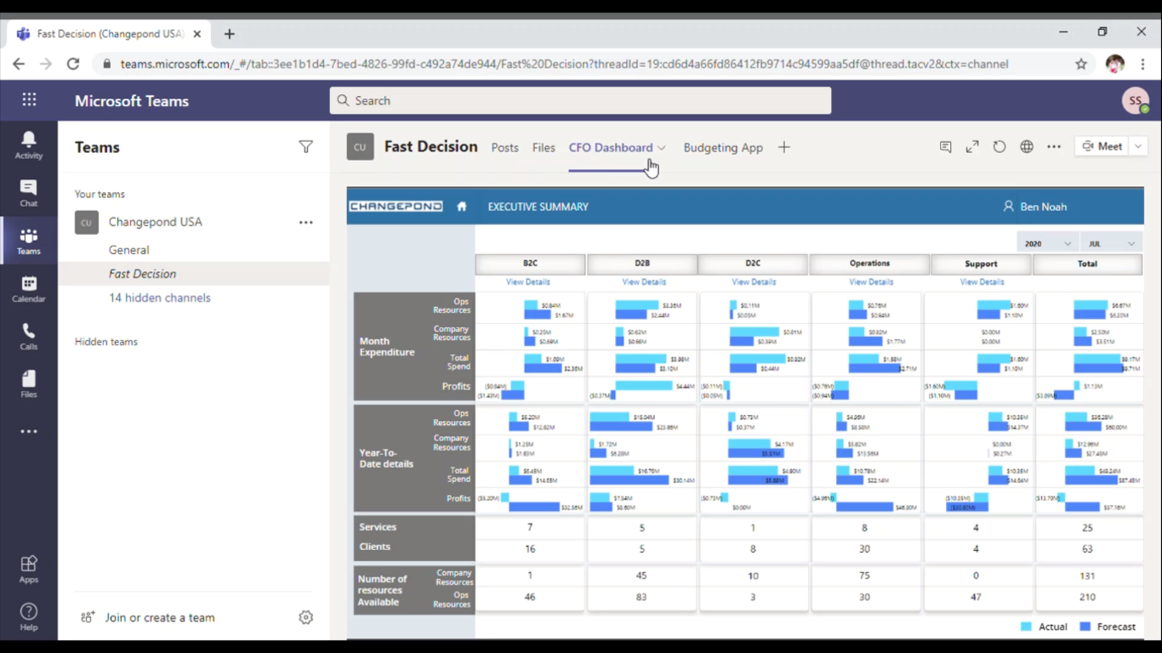

Fig 1: Dashboard

Drill down to identify the core problem and also understand underlying element that cause the problems

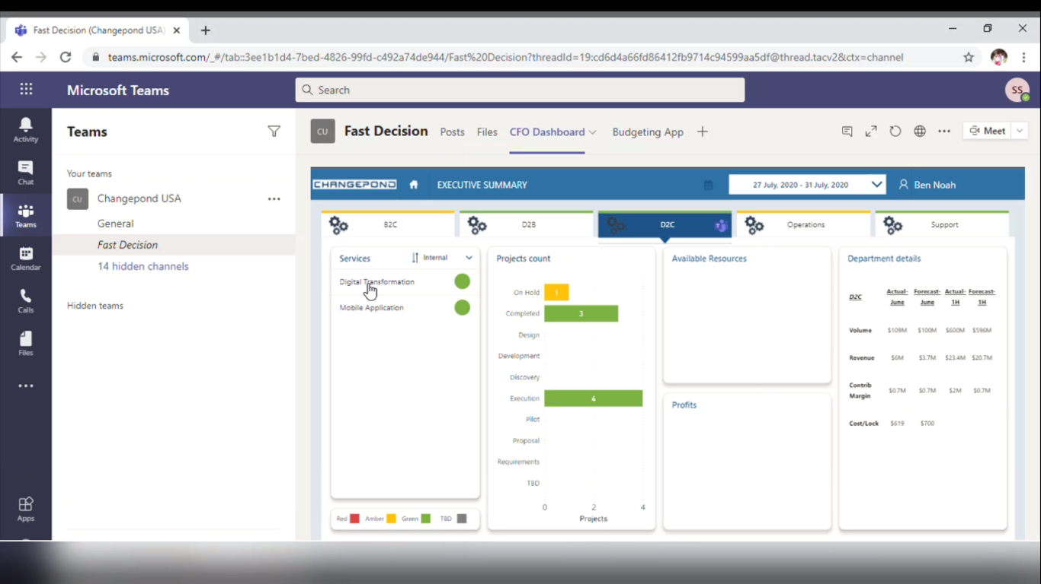

Fig 2: Service level details

We can easily identify the project under his/her team which needs to take necessary action. The overall details about the project also available for quicker understanding.

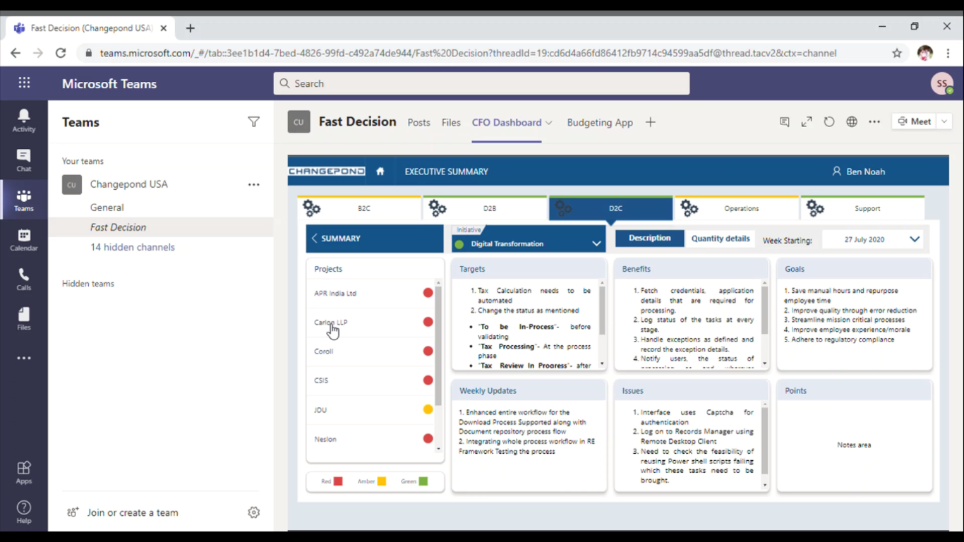

Fig 3: Projects level details

The qualitative information will be shown to understand the situation better so that the Top management executives can review and take necessary action against the problems.

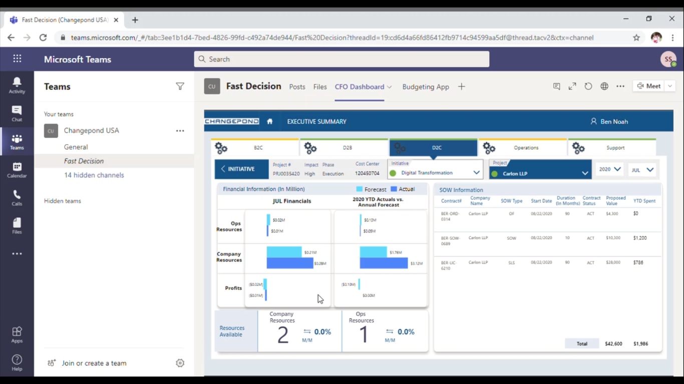

Fig 4: Qualitative details for a particular project

After review the company or projects performance, The Top management executive seamlessly communicates to the Head of other respective departments through internal collaboration channel (We built communication channel using Microsoft Teams)

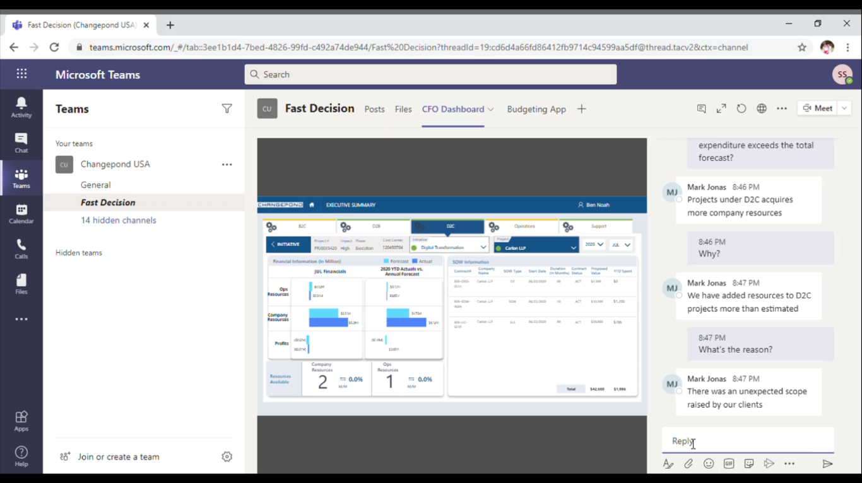

Fig 5: Internal communication between departments

After find out the real reason for the cause the CEO/CFO can easily act upon to resolve the problem. We provide a feature through which we can access or integrate any other 3rd party applications or systems to take corrective actions against problems. This is how our Fast Decision product helps customer to Diagnose, Decide and Act faster in business problems